Technical Solution to Real world Problem (TARP)

CSE1901

REVIEW - 2

Faculty: S.A. Sajidha Slot: TAA1

TOPIC: Disease Detection In Plants

TEAM:

Bipasa Mukherjee (19BCE1680)

Hima Rani Mathews (19BCE1532)

Talatala Rahul Reddy (19BCE1778)

Manav Rakesh Kumar Modi (19BCE1298)

Achintya Kumar Satyayan (19BCE1616)

**TALATALA RAHUL REDDY (19BCE1778)**

**PAPER I**

*Rajasekaran, C., et al.* ***"Turmeric Plant Diseases Detection and Classification using Artificial Intelligence."*** *2020 International Conference on Communication and Signal Processing (ICCSP). IEEE, 2020*

**ABSTRACT**

In a paper by Rajasekaran C et al. they have proposed a methodology where they have compared VGG-16 (Visual Geometry Group) architecture in CNN and AlexNet architecture for diseased image classification and detection. They carried out the proposed work using the Raspberry Pi hardware module and other hardware modules. The Deep Learning algorithms were fed into the Raspberry Pi, which then detects the disease on the turmeric plant by taking a picture of the turmeric leaf.

Blotch Disease is the one of the dominant diseases that affect turmeric plants, Blotch disease is caused by Taphrina maculans, an ascomycetous fungus, its symptoms are small, oval, rectangular or irregular brown spots on either side of the leaves which soon become dirty yellow or dark brown.

These irregular or dissimilarities on the leaves are identified and enhanced using image segmentation technique and object-recognition models like VGG-16 and AlexNet.

**METHODOLOGY**

***Hardware Perspective:***

The proposed hardware model consists of Internet Protocol camera (IP), Raspberry pi 4, Router and Field monitor.

Step 1: Image acquisition is done using the IP camera in the agricultural field, this IP camera is connected to the Raspberry Pi module through the router, where these raw images are fed into the module where further analysis and processing is done.

Step 2: After fetching the data from the IP camera, the image is enhanced and segmented to get better features that are useful for the algorithm, these extracted features are given as input to the algorithm which then gives an output.

Step 3: The output contains the name of disease and precautionary measures to cure the disease.

***Software Perspective:***

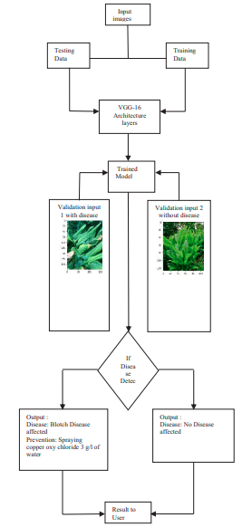Step 1: All the images are taken from the newer version of Plant Village Dataset where the raw images are sized down by reducing the pixel size to be fed as input to the algorithm.

Step 2: Before the images are given to the algorithm, they are enhanced by cropping the Region of Interest (ROI) area and performing contrast enhancement. There are around 700 dataset images used in this model for testing and training purposes into which two sets of folders contain and mentioned diseased and non-diseased where 30% of dataset are in testing folder and remaining 70% dataset are in training folder.

Step 3: These enhanced images are fed into the algorithm using ImageData Generator which is used to pass data to the model and for training and testing data to fit the generator by importing model.fit_generator.

Step 4: The above data is passed through the VGG-16 layers and then through the trained model and if the disease is detected, then the necessary output is printed. The above detection of disease is carried out using the following layers in the VGG-16 architecture:

1. Two convolution layers of 64 channel with 3x3 kernel and same padding
2. One maxpool layer of 64 channel with 2x2 pool size and stride 2x2
3. Two convolution layers of 128 channel with 3x3 kernel and same padding
4. One maxpool layer of 128 channel with 2x2 pool size and stride 2x2
5. Three convolution layers are of 256 channels with 3x3 kernel and same padding
6. One maxpool layer of 256 channel with 2x2 pool size and stride 2x2
7. Three convolution layers of 512 channel with 3x3 kernel and same padding
8. One maxpool layer of 512 channel with 2x2 pool size and stride 2x2
9. Three convolution layers of 512 channel of 3x3 kernel and same padding
10. One maxpool layer of 512 channel with 2x2 pool size and stride 2x2
11. Two Dense layer of 4096 units
12. Two Dropout layer of 4096 units
13. One Dense Softmax layer of 2 units

Apart from that ReLu activation, Softmax activation and Adam Optimiser are used.

Step 5: New images are fed into the algorithm by following the above steps and then output is printed.

**RESULTS**

Similarly, the AlexNet architecture model is trained and then both of these models are compared against each other and the VGG-16 model has clearly outperformed the AlexNet model in all parameters such as accuracy, recall and precision. The overall accuracy obtained by VGG-16 was 0.9624 and loss was 0.8719 which was better accuracy value as compared to Alex-net where it had an overall accuracy of 0.0525 and loss of 40.4076.

Accuracy and Loss graph of AlexNet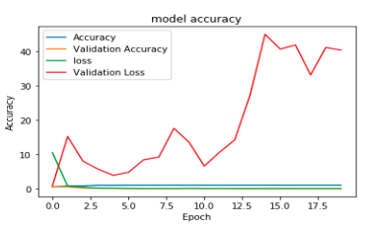

Accuracy and Loss graph of VGG-16

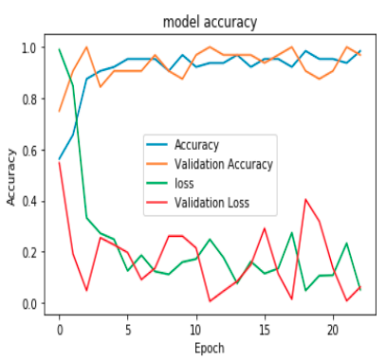

**PAPER II**

*Aversano, Lerina, et al.* ***"Tomato diseases Classification Based on VGG and Transfer Learning."*** *2020 IEEE International Workshop on Metrology for Agriculture and Forestry (MetroAgriFor). IEEE, 2020*

**ABSTRACT**

In a paper by Aversano et al. they have proposed a methodology where they have used three different CNN models which were previously trained, VGG-19, Xception and ResNet-50 using a transfer learning method to identify the disease that the tomato plant has. Transfer learning uses knowledge of one type of problem to solve similar problems. It allows to use a pretrained network and use it to learn a new activity.

Bacterial Spot, Early Blight, Late Blight, Leaf Mold, Septoria Leaf spot, two spotted spider mite, Target Spot, Mosaic Virus & Yellow Leaf Curl Virus are few of the dominant diseases that deteriorate the tomato plants. The above 9 classes are utilized in the proposed work.

These irregular or dissimilarities on the leaves are identified using object-recognition models like VGG-19, Xception & ResNet-50 and the desired output is produced.

**METHODOLOGY**

They carried out the proposed work using the Plant Village Dataset which is publicly available.

***Implementing Transfer Learning***

The most common process to implement transfer-learning using a neural network model is as follows:

1. Acquire layers from a previously trained model
2. Freeze them, to avoid overwriting weights during subsequent training steps
3. Append additional trainable layers on top of the trained frozen layers that will translate the pre-trained features into prediction for the new classification task

Then the resulting model can be trained on the new dataset. After the model is trained, a fine-tuning step has been performed which consists of making the entire model (or only some internal layers) trainable again. This allows re-training on the new data.

In the fine-tuning step they have adopted a very low learning rate to avoid overfitting and prevent too high changes to pre-trained weights that can potentially corrupt the old features extraction. This fine tuning step led to the overall model improvements, by adapting the pre-trained features to better suit the new task of detecting disease on the tomato plant.

***VGG-19 Model***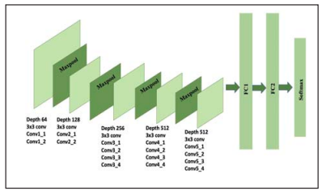

The VGG-19 architecture receives a fixed size RGB image (224*224) as input. The image is passed through a stack of convolutional layers using 3 × 3 filters, with a step size of 1 pixel, which covers the whole notion of an image. Spatial fill was used to preserve the spatial resolution of the image. It has 16 layers of convolution followed by 3 fully connected layers. The first two have 4096 channels each, the third contains 1000 channels and performs object classification. The final layer is a soft-max feature. All hidden layers are equipped with the rectification non-linearity, RELU function.

***Xception Model***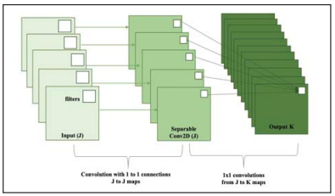

Xception model has overtaken the previous records in both speed and accuracy held by the Inception architecture. It relies on two main points: Depthwise Separable Convolution and Shortcuts between Convolution blocks as in ResNet. Its architecture is based on depthwise separable convolution layers and consists of three major sections: Entry Flow, Middle Flow, and Exit Flow. All Convolution and Separable Convolution layers are followed by batch normalization. It takes the principles of Inception to an extreme, instead of partitioning input data into several compressed chunks, it maps the spatial correlations for each output channel separately and then performs a 1x1 depthwise convolution to capture cross-channel correlation.

***ResNet-50 Model***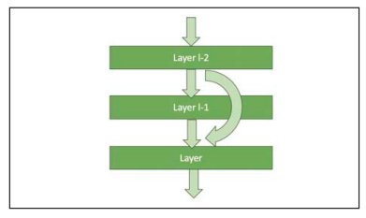

ResNet-50 is a very deep convolutional neural network, made up of 50 layers, which with the help of a technique known as skip connection has opened the way for residual networks. The processed data transferred to the next level is also added to the output of the previous ones, according to a defined scheme, this is called skip connection and it's very crucial to train a model with a large number of levels.

ResNet-50 is an innovative solution to the problem of the vanishing gradient, which occurs in neural networks when they train themselves through the backpropagation process, based on the descent of the gradient, moving the loss function down to find the weights that minimize it. If there are too many layers, repeating the multiplication can cause the gradient value to get smaller and smaller, eventually disappearing, resulting in saturation or even performance degradation with each additional layer.

ResNet-50 stacks the levels that initially do nothing and skips them, reusing the activations from previous levels. The jump initially compresses the network into only a few levels, which allows for faster learning. Then, when the net trains again, all the layers are expanded and the "residual" parts of the net explore more and more the feature space of the source image.

**RESULTS**

All the above three models are compared against each other and the VGG-19 model has a better performance than the other two proposed models, Xception and ResNet-50. They were able to achieve an overall accuracy of 0.97 for VGG-19, 0.95 for Xception and 0.60 for ResNet-50.

Precision of VGG-19, Xception and ResNet-50

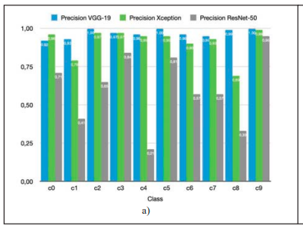

Recall of VGG-19, Xception and ResNet-50

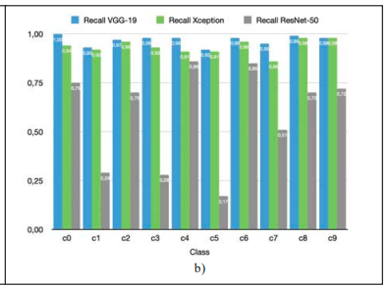

F1 Score for VGG-19, Xception and ResNet-50 networks

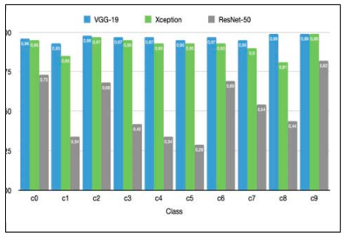

**ACHINTYA KUMAR SATYAYAN(19BCE1616)**

**PAPER III**

*KP, A., & Anitha, J. (2021). Plant disease classification using deep learning. 2021 3rd International Conference on Signal Processing and Communication (ICPSC). doi:10.1109/icspc51351.2021.94*

**ABSTRACT**

Agriculture plays a crucial role in the Indian economy. Early detection of plant diseases is very much essential to prevent crop loss and further spread of diseases. Most plants such as apple, tomato, cherry, grapes show visible symptoms of the disease on the leaf. These visible patterns can be identified to correctly predict the disease and take early actions to prevent it. The conventional method is the farmers or plant pathologists manually observe the plant leaf and identify the type of disease. In this project, a deep learning model is trained to classify the different plant diseases. The convolutional neural network (CNN) model is used due to its massive success in image-based classification. The deep learning model provides faster and more accurate predictions than manual observation of the plant leaf. In this work, the CNN model and pre-trained models such as VGG, ResNet, and DenseNet models are trained using the dataset. Among them, the DenseNet model achieves the highest accuracy.

**METHODOLOGY**

Plant disease detection is a significant challenge in the agriculture sector. Some of the plants show visible symptoms on the plant leaf. These leaf patterns can be used to identify different diseases and take immediate action to prevent the spread. The working model uses convolutional neural networks and transfer learning to classify different plant leaf diseases. CNN is a type of deep learning neural network and has good success in image-based classification. The proposed system is faster and more accurate than the conventional way of manual observation of each plant leaf. Deploying such a model into a mobile application can help farmers detect different plant diseases using mobile cameras and take necessary actions to avoid disease spread. For this study, the images of grape plant diseases from the Plant Village dataset are used to train the model. The CNN (Convolutional neural network), VGG19, ResNet-152v2, and DenseNet models are trained using the plant dataset.

The convolutional neural network is used in this work to classify different plant diseases.The first layer in the model is the convolution layer that is used to extract features from an input image. The convolution layer applies different filters on the image to create a feature map and help to extract different features. The convolution layers are followed by pooling layers. The pooling layers reduce the image size and the no of parameters. Common types of pooling operations are max pooling, average pooling, and sum pooling. After convolution and pooling operations, the matrix is flattened into a vector and is passed into the fully connected layer. In this study, rectified linear activation function or ReLU activation function is used for the convolution layer and a Softmax activation function for the output layer.

Transfer learning is a method in which pre-trained models are reused for a new task instead of developing models from scratch. These models are trained on a large number of images and can improve the accuracy of prediction. In this study, VGG, DenseNet, and Resnet models are trained using the transfer learning technique. The results of these models are compared with each other, and the performance is analyzed.

IMPLEMENTATION DETAILS

A. Dataset

The data for this study is gathered from the Plant village dataset. The Plant Village dataset consists of more than 55,000 images with 38 classes of 14 different plant species. Out of 38 classes, 12 are healthy, and 26 are diseased leaf classes. In this study, the grape plant leaf images are taken, containing 4,062 images with four classes. The classes are healthy, black rot, Esca (Black Measles), and Leaf blight (Isariopsis Leaf Spot). The dataset consists of 423 healthy leaves, 1,180 black rot affected leaves, 1,383 esca affected leaves, and 1,076 Leaf blight affected images. Deep learning models require a large dataset to achieve a good performance. Using the Image data generator in Keras, the images are resized into 224x224 pixel size, and augmentations such as rotation, zoom, and shift were applied. The primary purpose of the augmentation process is to expand the dataset and prevent overfitting during the training stage. To perform the experiments, the dataset is split into training and validation set in the ratio of 80:20. The training set contains 3,258 images, and the validation set contains 812 images.

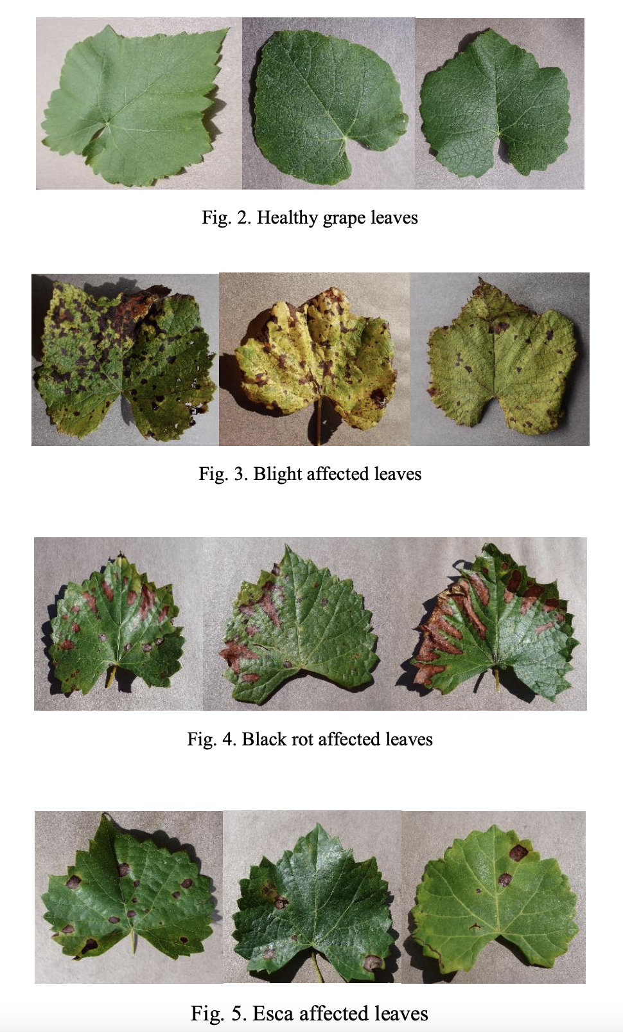

B. Training Neural Network

In this study, a convolutional neural network and popular pre-trained models such as VGG, ResNet, and DenseNet are trained using the plant dataset, and results are compared. The CNN model used contains pairs of convolution and pooling layers. The convolution layers perform filters on the input image and extract the features. The pooling layers reduce the size of the input image and reduce the computation performed in the network. The CNN model is trained using the training set for 20 epochs. The optimizer used is Adam, and the loss function selected is categorical cross-entropy. Popular pre-trained models such as VGG, ResNet, and DenseNet are used and the experimental results are compared. The images are resized to 224x224, which is the default size accepted by the VGG, ResNet, and Densenet models.

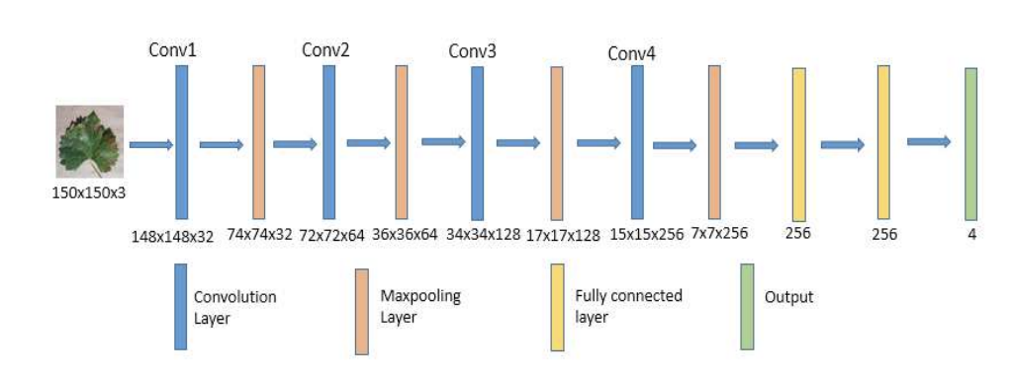

RESULTS AND CONCLUSION

This study facilitates the early diagnosis of plant diseases to prevent crop loss and the spread of diseases. The CNN model is used to predict different plant diseases correctly. The performance of various pre-trained CNN models such as VGG, ResNet, and DenseNet is observed, and then based on performance metrics, the DenseNet model is found to be more accurate. The model's testing is done using performance evaluation metrics such as accuracy, precision, recall, and F1 score. The DenseNet model achieved the highest accuracy of 98.27%.

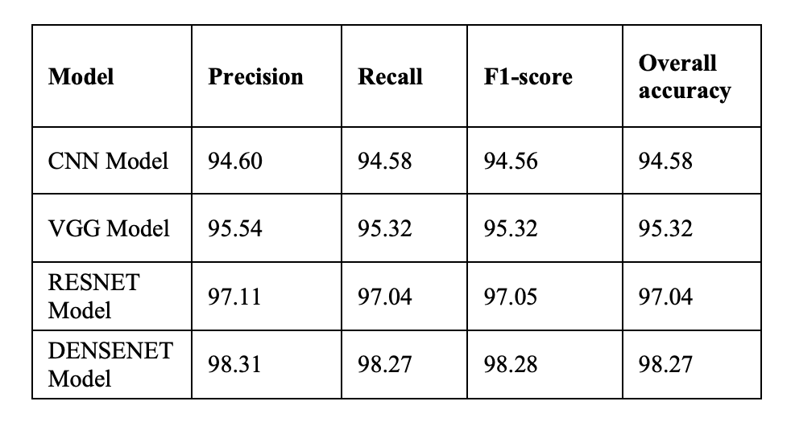

**PAPER IV**

*Li, X., & Rai, L. (2020). Apple Leaf Disease Identification and Classification using ResNet Models. 2020 IEEE 3rd International Conference on Electronic Information and Communication Technology (ICEICT). doi:10.1109/iceict51264.2020.9*

**ABSTRACT**

With the development and popularization of intelligent agricultural system, more and more research and attention have been paid to the detection and identification of leaf diseases. We used data sets of apple grey-spot disease, black star disease, cedar rust disease and healthy leaves to study the identification and classification of apple leaf diseases. Image segmentation SVM classifier and ResNet and VGG convolutional neural network model were used for comparison and improvement. In the final experiment, ResNet-18 with fewer layers of ResNet obtained an accuracy rate of 98.5% achieving better recognition effects.

**METHODOLOGY**

In recent years, with the vigorous development in fruit industry and the continuous increase of apple plantation, various diseases and insect pests have gradually increased their influence on apple yield, which seriously affected the economic income of farmers.In this paper, we adopted the method based on imaging and machine learning to identify classification of apple leaf diseases by shading background to extract only the leaf image. The image is converted into color space image, determine the L *, a * and b * channel threshold, these channels will be segmented from the background leaves, will remove the background image is converted into color space leaves, of a, b, channel using Otsu segmentation algorithm. We obtained the data set of apple leaves from the website of Plant Village. After using the support vector machine (SVM) model, we continued to use the ResNet and VGG parameter training network to conduct experiments, and found that the accuracy is reached 90% and 97.8% and 92% respectively, providing a way for large-scale automatic plant disease identification and detection.

In order to analyze and extract apple leaf diseases morereliably, we segmented the leaf images. Initially, shade thegreen part of the apple leaf and the background area. In this way, the spot areas containing only the apple leaf disease can be extracted. These spots exhibit specific color and texture characteristics for different diseases. A SVM classifier with these characteristics is trained to detect and distinguish diseases. The basic steps of the proposed disease detection method are as follows: (1) The image was converted into lab image, threshold segmentation was carried out, and the background was removed, (2) Disease areas of the leaves were obtained by removing the green mask, (3) The texture feature and color moment feature of grayscale co-occurrence matrix were calculated, (4) The SVM is used for training and the model is obtaine, (5) After repeating process with the test picture, SVM was used for evaluation. ResNet-18 and ResNet-34 and VGG-16 neural networks were used to carry out network training on the original image of leaf disease, the pre-extraction image of disease region and the data enhancement image, respectively, to verify the accuracy.

A. Data Set

The web site Plant Village (www.plantvillage.org) offers free access to the open database, which collected data of 14 plant types, and there are more than 50,000 visible leaf images of the diseases, including 38 species category tags. From this database, in this study, we extracted images of apple leaves of 4 categories, including 3 diseases and one healthy leaf. The total number of images is 2700 pieces. Preprocessing is transformed into lab image to segment diseases and construct two classifiers of health-disease and disease-disease.

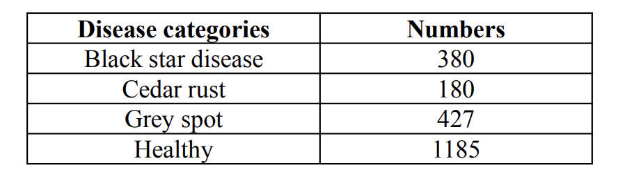

(a) Lab image segmentation: The image is converted into lab image to determine the threshold of L*, a* and b*channels, which segment the leaves from the background.We determined the threshold values for L*, a*, and b*channels, and based on the threshold generated masks to remove the background and split the leaves from the background.The selection of threshold range in channel L*,a* and b* histogram analysis is done.

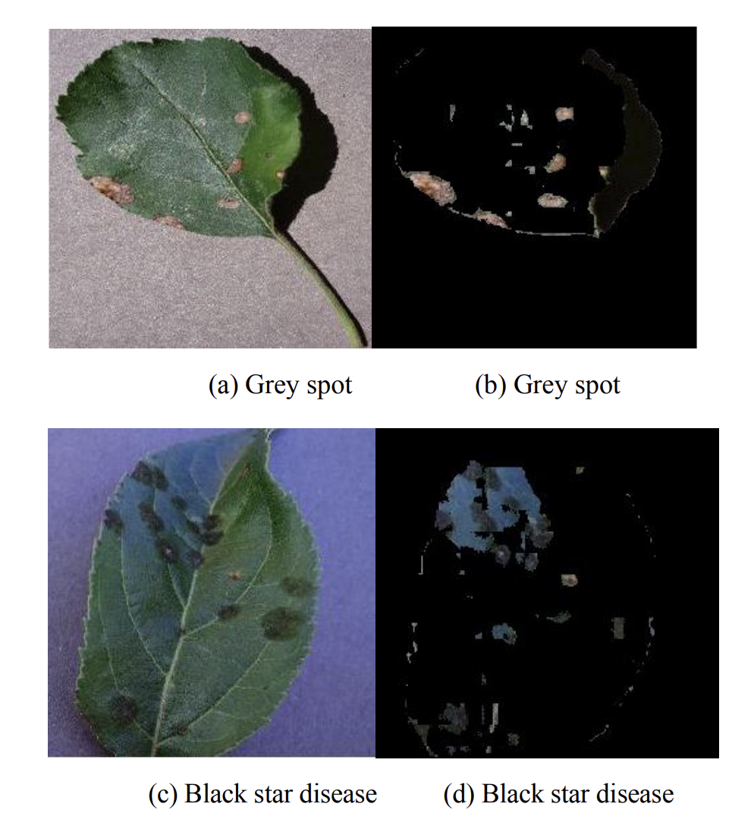

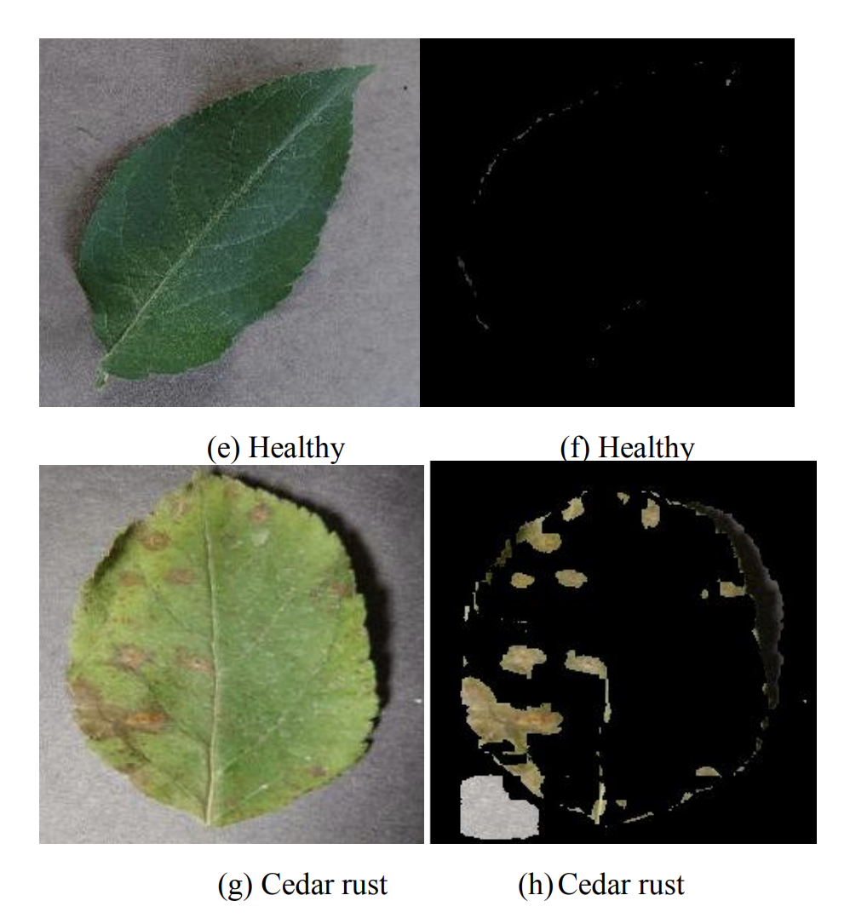

(b) Otsu segmentation of Lab images: According to the histogram performance, the histogram of the upper leaf has a trough. Therefore, the use of OTSU (the largest intercategory variance method) has better effect. The leaf image with background removed is converted into lab image, and the use of OTSU segmentation algorithm for a, b, and channel can also better segment the disease region.

B. Feature Extraction and Classifier

The grayscale symbiosis matrix (GLCM) was used to extract statistical texture features, contrast, correlation, energy and uniformity, mean, standard deviation, entropy, skew and energy, a total of 10 features. Therefore, a 10- dimensional feature vector is extracted from each sample, and multi-class SVM with “linear” kernel is used for classification.

C. Training of CNN

The deep structure of CNN model is crucial to itscharacteristic learning ability. However, as the number oflayers of the CNN model increases, the accuracy will firstrise to saturation. If the number of layers of the networkcontinues to increase, the accuracy will decline, which is the“degradation” phenomenon .

After flipping, shifting, scaling, etc., the data of appleleaves with gray spot disease, black star disease, healthy andcedar embroidery disease were enhanced. Considering thesmall number of original data and processed images, themigration learning method with global fine-tuning isproposed to be used for training. Finally, ResNet-18 andResNet-34 are applied to three different databases. The VGGmodel is used to carry out experiments on the data set. VGG16 is a very symmetric network, where each layer increasesor decreases exponentially, and there is a fixed convolutionmodel and pooling model.

RESULTS

We applied the proposed traditional algorithm to a dataset containing 2172 images of apple disease leaves from the open dataset “Plant Village”. The experimental data included 1185 healthy leaves and 987 diseased leaves. In the experiment, the database is divided into two sets: the training set contains 1276 images (60%) and the test set contains 850 images (40%). For classification purposes, multiple classes of support vector machines are used. In order to evaluate the performance of the classification model, performance parameters such as accuracy, sensitivity, recall rate and F1 score were calculated. When using image segmentation and support vector machine model, the accuracy of classification test is 90%. In order to make the model more robust, we used the ResNet-18 and ResNet-34 networks to train and classify the original image and the image after image segmentation and extraction, with an accuracy of 99% and 97%. Then VGG-16 algorithm was used to compare with ResNet.In addition, this paper also adopts the ResNet-18 and ResNet34 network training models for the original images after data enhancement, and the accuracy reaches 97%.

Disease-Disease classifier: Apple grey spot disease, apple black star disease and Apple cedar rust disease were classified. GLCM features of segmated images wereextracted. Healthy and diseased leaves were trained usingSVM and tested after the results.

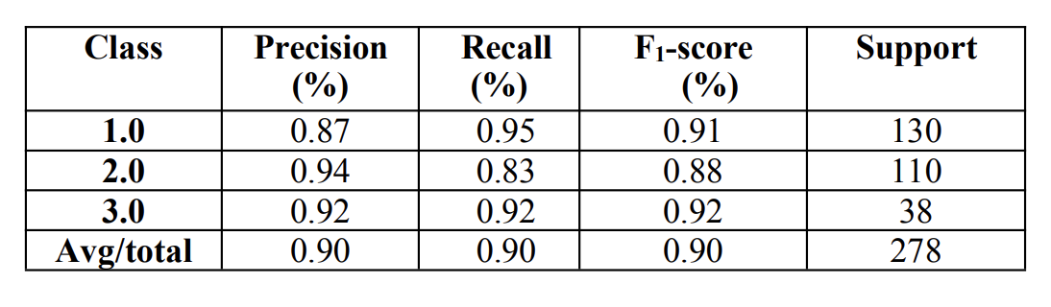

Health-disease classifier: Classify healthy leaves or diseases,extract GLCM features of segmentation images, train healthyleaves and disease leaves using SVM, and test the resultsafter completion.

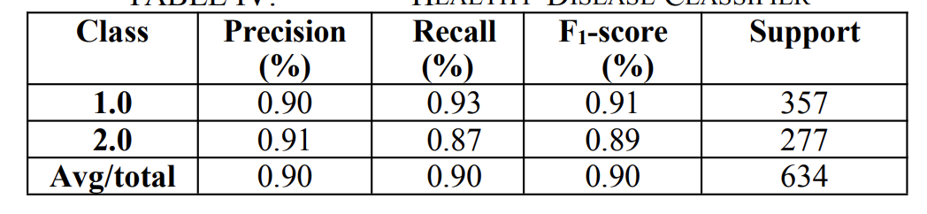

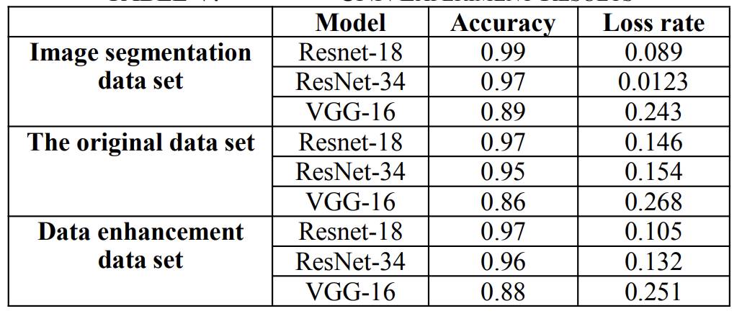

**MANAV RAKESH KUMAR MODI-19BCE1298**

Paper V

Plant disease and pest detection using deep learning-based features

<https://journals.tubitak.gov.tr/elektrik/issues/elk-19-27-3/elk-27-3-6-1809-181.pdf>

Authors: MUAMMER TÜRKOĞLU, DAVUT HANBAY

Abstract: The timely and accurate diagnosis of plant diseases plays an important role in preventing the loss of productivity and loss or reduced quantity of agricultural products. In order to solve such problems, methods based on machine learning can be used. In recent years, deep learning, which is especially widely used in image processing, offers many new applications related to precision agriculture. In this study, we evaluated the performance results using different approaches of nine powerful architectures of deep neural networks for plant disease detection. Transfer learning and deep feature extraction methods are used, which adapt these deep learning models to the problem at hand. The utilized pretrained deep models are considered in the presented work for feature extraction and for further fine-tuning. **The obtained features using deep feature extraction are then classified by support vector machine (SVM), extreme learning machine (ELM), and K-nearest neighbor (KNN) methods. The experiments are carried out using data consisting of real disease and pest images from Turkey. The accuracy, sensitivity, specificity, and F1-score are all calculated for performance evaluation. The evaluation results show that deep feature extraction and SVM/ELM classification produced better results than transfer learning. In addition, the fc6 layers of the AlexNet, VGG16, and VGG19 models produced better accuracy scores when compared to the other layers.**

Keywords: Plant disease and pest detection, convolutional neural networks, deep learning architectures, feature extraction, classifier methods

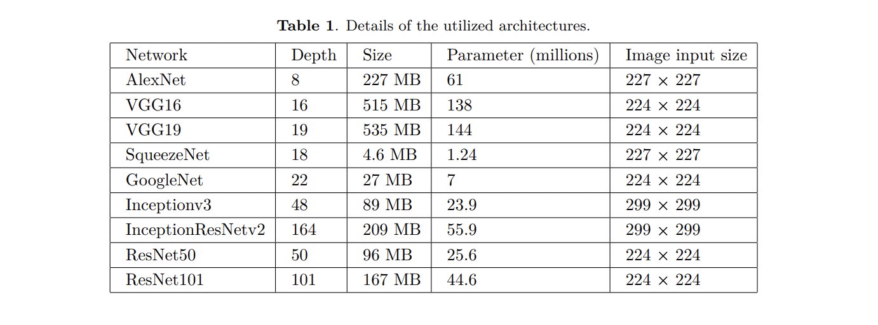

**Classifiers:** In this paper, traditional classifier methods of SVM, ELM, and KNN are used to construct the classification model of deep features extracted from specific layers of pretrained deep learning models.

**Dataset:** The dataset used to test the performance of the proposed method includes images of plant diseases common to the Malatya, Bingöl, and Elazığ regions of Turkey (Figure 1). These images were obtained with a Nikon 7200d camera. Each image in this dataset consists of 4000 × 6000 resolution and three-channel (RGB) color images. Table 2 lists the names and numbers of plant diseases and pests in this dataset.

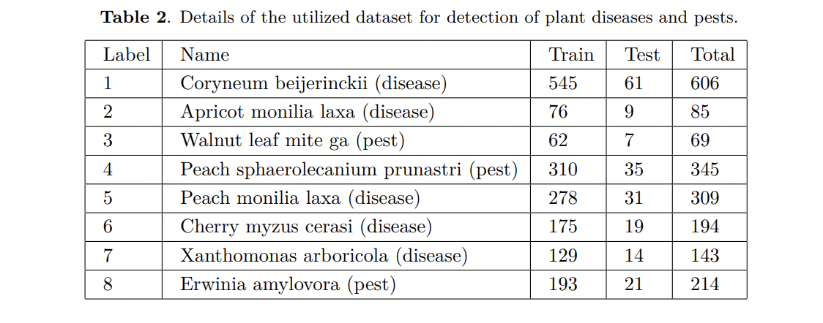

**Proposed method:** In this study, we applied deep feature extraction from various fully connected layers and transfer learning based on pretrained deep learning architectures. The scheme of the proposed study is illustrated in Figures 2 and 3. Transfer learning and deep feature extraction are detailed in the following subsections

FIG2:

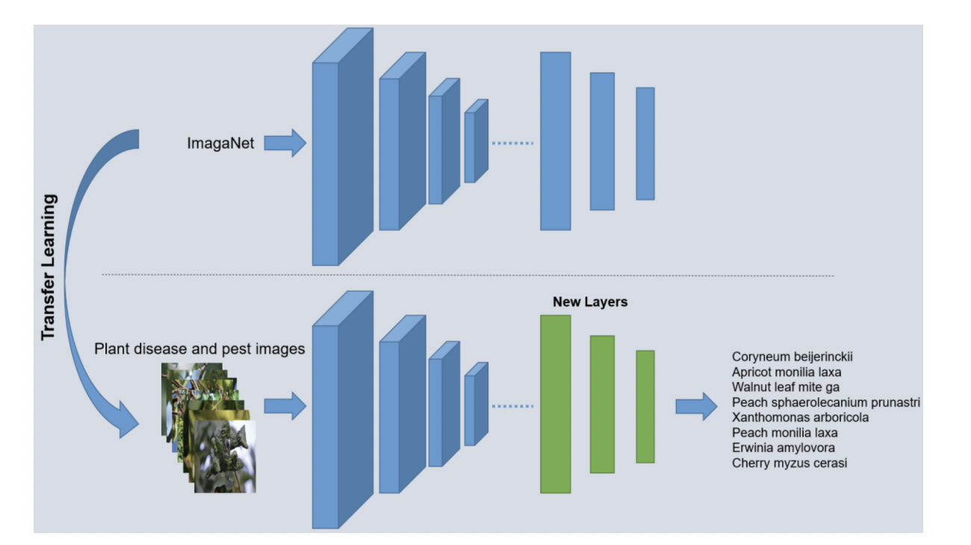

**Deep feature extraction:** Deep feature extraction is based on extracting features learned from a pretrained convolutional neural network. These features are used to train machine learning classifiers. In other words, this method is based on the extraction of deep features from the fully connected layer of pretrained networks. In this study, **effective deep features were extracted from a certain layer of deep learning models, which are GoogleNet, ResNet50, ResNet101, InceptionV3, InceptionResNetV2, and SqueezeNet and pool5-drop_7x7_s1, fc1000, fc1000, predictions, predictions, and pool10, respectively.** In addition, feature vectors were obtained from the these layers of the GoogleNet, ResNet50, ResNet101, InceptionV3, InceptionResNetV2, and SqueezeNet models: 1024, 1000, 1000, 1000, 1000, and 4096, respectively. The obtained deep features are employed in the classification phase by using the traditional classifiers of SVM, ELM, and KNN, as shown in Figure 3.

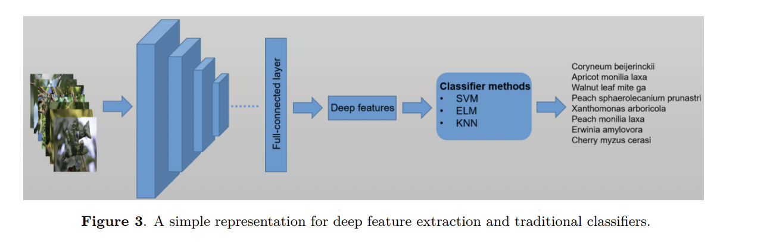

Step 1: Acquire plant images.

Step 2: Resize plant image according to deep networks using bilinear interpolation. For instance, color images sized 224 × 224 and 227 × 227 are used in ResNet50 and AlexNet, respectively.

Step 3: Features are extracted using the fully connected layers of the deep learning models.

Step 4: Classification is performed using the deep features with the SVM, KNN, and ELM classifiers.

The following steps summarize the transfer learning:

Step 1: Acquire plant images.

Step 2: Resize plant image according to deep networks using bilinear interpolation.

Step 3: Last three layers are removed from pretrained deep models and replaced by a fully connected layer, a softmax layer, and a classification output layer in order to adopt the pretrained CNN networks to solve the problem.

Step 4: Classification is performed using the newly created deep model.

**Results based on deep feature extraction with AlexNet, VGG16, and VGG19 models**

In this section, we use three different fully connected layers for deep feature extraction based on pretrained AlexNet, VGG16, and VGG19 models. For each of these models, deep features were extracted from the fc6, fc7, and fc8 layers. Then these features were calculated for their performance using the SVM, ELM, and KNN methods. The accuracy scores of these experimental studies are given in Table 3. In addition, these accuracy scores were evaluated according to the calculated average accuracy score across the folds and their standard deviations.

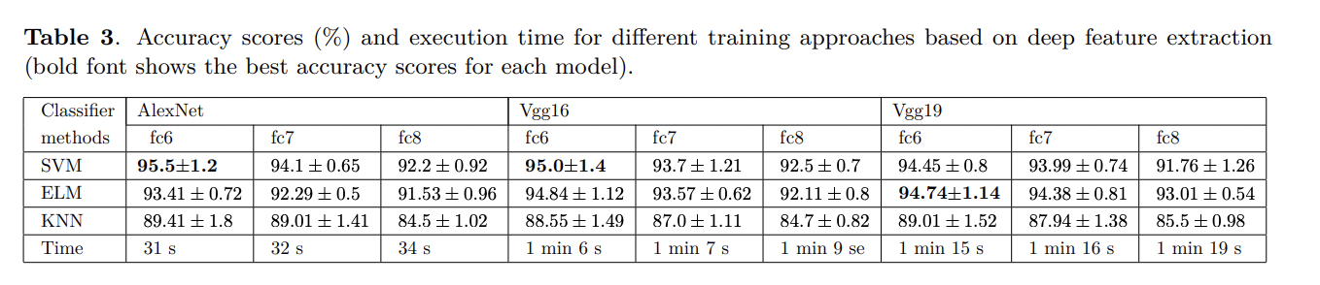

MORE RESULTS ON THE PAPER.

PAPER VI

Performance of deep learning vs machine learning in plant leaf disease detection

R. Sujatha , Jyotir Moy Chatterjee , NZ Jhanjhi, Sarfraz Nawaz Brohi

<https://www.sciencedirect.com/science/article/abs/pii/S0141933120307626>

TO CHECK : <https://sci-hub.hkvisa.net/10.1016/j.micpro.2020.103615> [DO NOT USE VIT WIFI]

**ABSTRACT :**

Plants are recognized as essential as they are the primary source of humanity’s energy production since they are having nutritious, medicinal, etc. values. At any time between crop farming, plant diseases can affect the leaf, resulting in enormous crop production damages and economic market value. Therefore, in the farming industry, identification of leaf disease plays a crucial role. It needs, however, enormous labor, greater preparation time, and comprehensive plant pathogen knowledge. For the identification of plant disease detection various machine learning (ML) as well as deep learning (DL) methods are developed & examined by various researchers, and many of the times they also got significant results in both cases. Motivated by those existing works, here in this article we are comparing the performance of ML (Support Vector Machine (SVM), Random Forest (RF), Stochastic Gradient Descent (SGD)) & DL (Inception-v3, VGG-16, VGG-19) in terms of citrus plant disease detection. **The disease classification accuracy (CA) we received by experimentation is quite impressive as DL methods perform better than that of ML methods in case of disease detection as follows: RF-76.8% > SGD-86.5% > SVM87% > VGG-19–87.4% > Inception-v3–89% > VGG-16–89.5%. From the result, we can tell that RF is giving the least CA whereas VGG-16 is giving the best in terms of CA.**

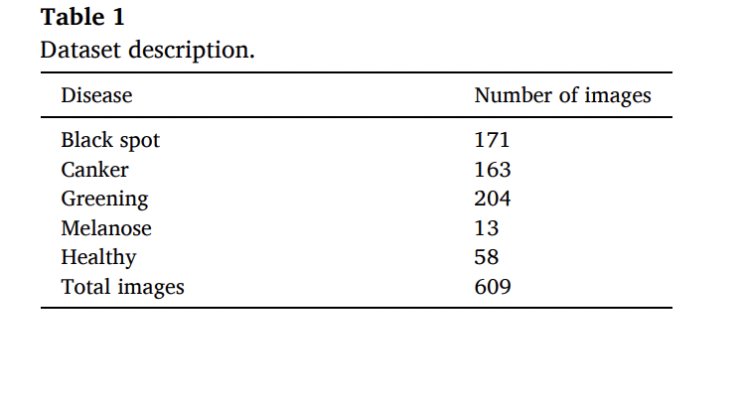

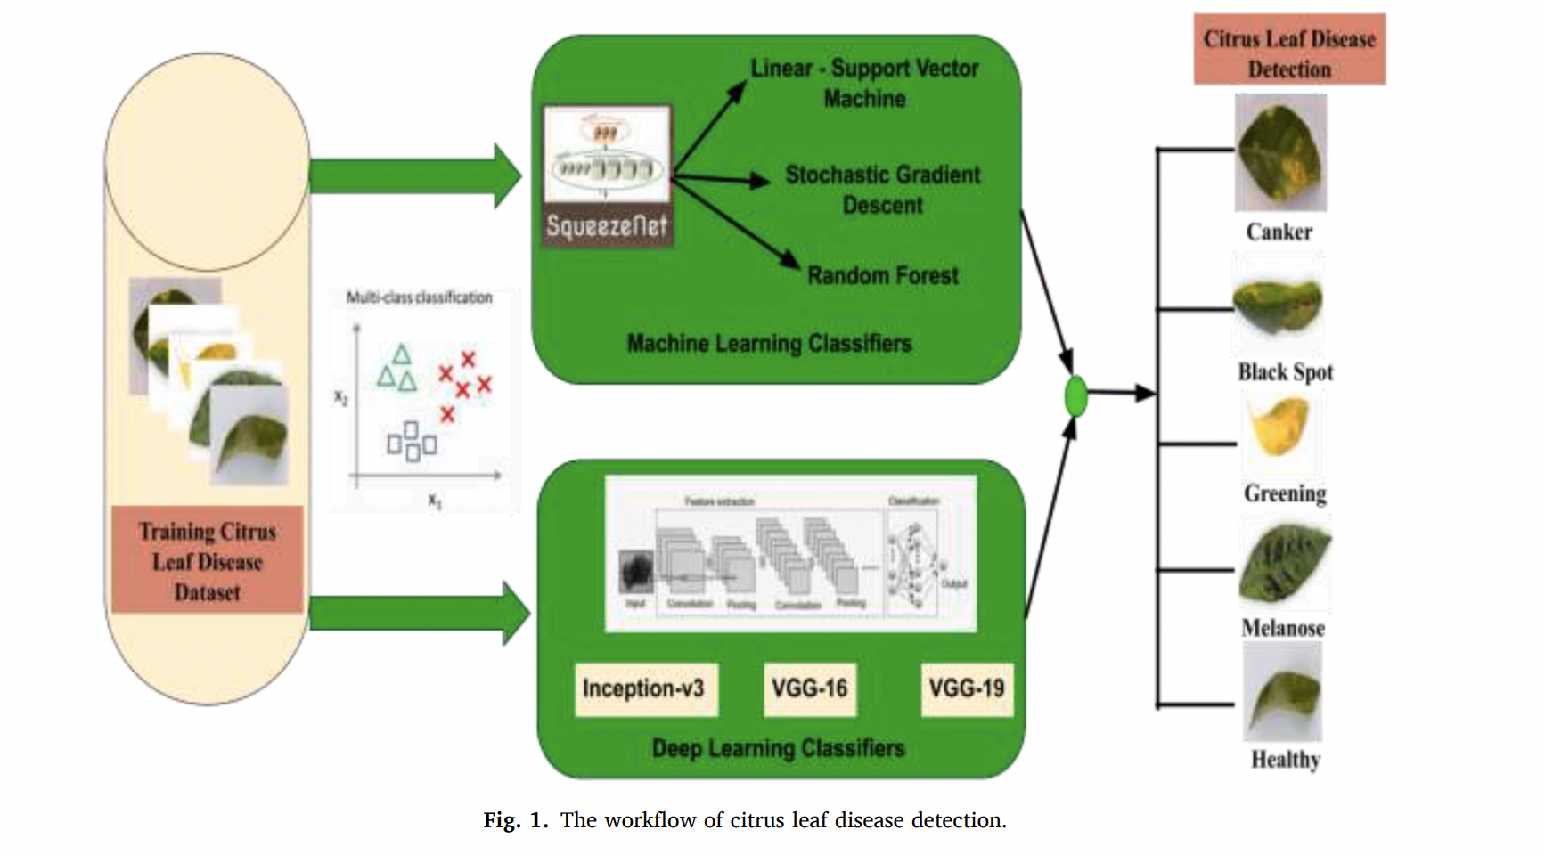

ML is meant for parsing the data and learning from it. Based on the requirement they applied to get the decision. Several algorithms were developed to address the various tasks of classification, clustering, association rule mining, outlier detection, and so on. Deep Learning is part of the evolution of ML that addresses the various types of datasets in a compatible manner. For the task of image recognition, CNN is used in a great manner in the deep learning environment. The resemblance of the structure correlates with the human recognition process from pupils till it gets converted into information that could be understood by the brain cells. The number of layers that constructs the architecture determines the working of the various CNN models. Based on the dataset size and deeper the network plays a vital role in the performance of the model. It is conveyed that a DL classifier helps in a better understanding of the considered dataset along with the deployed architecture. **The flow of work illustrated in Fig. 1. begins with the citrus leaf disease dataset and for the process of multi-class classification used the ML and DL classifiers to make the predictions.**

**DATASET:** The dataset used in this work was gathered manually with the guidance of experts and citrus research center, Government of Punjab, Pakistan located in Sargodha city. Captured the images with DSLR with the resolution of 72 dpi and size is 256 × 256 pixels respectively. The dataset is a collection of infected and healthy citrus leaves and fruits. In our work, we utilized the leaves dataset and it’s further classified based on the most prevalent leaf diseases.

RESULTS ON PAPER.

**BIPASA MUKHERJEE**

PAPER : VII

*Krishnaswamy Rangarajan, A., Purushothaman, R. Disease Classification in Eggplant Using Pre-trained VGG16 and MSVM. Sci Rep 10, 2322 (2020). https://doi.org/10.1038/s41598-020-59108-x*

**ABSTRACT**

Currently, the application of deep learning in crop disease classification is one of the active areas of research for which an image dataset is required. Eggplant (Solanum melongena) is one of the important crops, but it is susceptible to serious diseases which hinder its production. Surprisingly, so far no dataset is available for the diseases in this crop. The unavailability of the dataset for these diseases motivated the authors to create a standard dataset in laboratory and field conditions for five major diseases. Pre-trained Visual Geometry Group 16 (VGG16) architecture has been used and the images have been converted to other color spaces namely Hue Saturation Value (HSV), YCbCr and grayscale for evaluation. Results show that the dataset created with RGB and YCbCr images in feld condition was promising with a classifcation accuracy of 99.4%. The dataset also has been evaluated with other popular architectures and compared. In addition, VGG16 has been used as feature extractor from 8th convolution layer and these features have been used for classifying diseases employing Multi-Class Support Vector Machine (MSVM). The analysis depicted an equivalent or in some cases produced better accuracy. Possible reasons for variation in interclass accuracy and future direction have been discussed.

**METHODOLOGY**

Disease dataset and configuration of the system. In this study, five major diseases (as shown in Fig. 1) due to pests and pathogens have been identified. These diseases caused extensive damage to the selected crop under favorable conditions. A dataset for these diseases have been created with the images of isolated leaf samples using different smartphone cameras in laboratory conditions. Te leaf was placed on a uniform white background

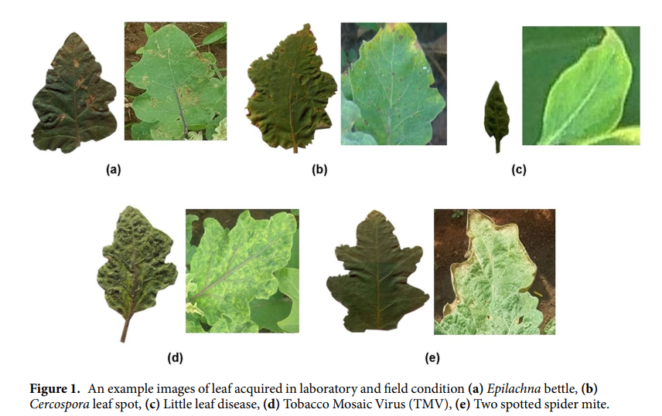

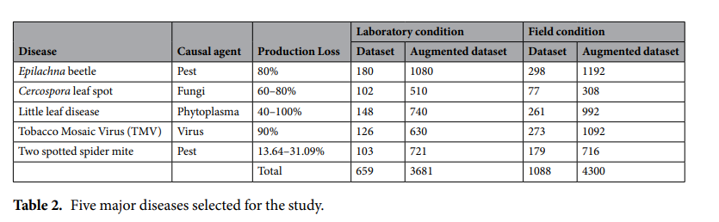

with a glass sheet on top to ensure fatness during image acquisition. An another leaf dataset was created using the images acquired directly from the feld, employing the same smartphones. All these images in the dataset were manually categorized to specific diseases with the consultation from the experts. The images acquired in laboratory conditions were preprocessed in order to segment the leaves from the background. However, no segmentation was performed in the field images. The background of the leaf images mainly consists of other overlapping leaves of the same or other plants, weed and soil. The ambience of the images also varied within the image sets of the same category. The dimensions of the images were resized to 224×224 pixels according to the input requirement of the pre-trained VGG16. The deep learning models trained with limited dataset will result in an overfitting of the model. Hence, augmentation of the dataset has been performed to increase the number of sample images using image transformation such as random angular rotation and translation. This introduces additional uncertainties by which a robust trained model suitable for better disease predictive capability, can be created.

The study has been conducted with two different approaches. In the first approach, the image dataset was converted from Red Green Blue (RGB) space into different color scales namely Hue Saturation Value (HSV), YCbCr and gray and these images are stored as Joint Photographic Expert Group (JPEG) format. HSV color space has been used traditionally in few studies for identification of diseases and it is the closest system to human experience on colors 26–29. Tese studies reported an improved identification of certain diseases which promoted the feature extraction. However, the YCbCr color space is widely unexplored for disease classification that has prominent luminance information in component Y along with Cb and Cr which is the difference between blue and red channel value from a reference value26. These image datasets are then provided as input separately to the pre-trained VGG16 architecture and the training process is carried out with the fully connected layer. The training process has a forward and backward pass. During the backward pass (i.e., backpropagation), the derivative of the loss function is propagated back to the initial layers and the gradient corresponding to a neuron which significantly influences the output is found. Based on these gradients, the learnable parameters are updated using a stochastic gradient descent algorithm and the resulting error is estimated. The number of iteration is a user-defined setting beyond which the training stops and then the validation is performed.

In the second approach, features are extracted from these previously trained different layers of VGG16 beginning at the 8th convolution layer and fed as input to the MSVM. The experiment is performed for each color space. An earlier study by Liang et al. 11, demonstrated the recognition of rice blast disease using CNN with SVM. But the features are extracted from the last convolution layer and classification using the SVM were analyzed. In our case, the ability of features from each layer beginning at the 8th layer in classifying the diseases were evaluated. The reason for the selection of the 8th layer is due to the limitation in the capacity of RAM as feature parameters from the previous layers demand more memory space (greater than 8GB).

**RESULTS**

The created dataset was split into a training and test set with 80% and 20% respectively. The images were selected randomly for each set and hence accuracy varies according to the selected images. As consistency is questionable, fve trials were carried out to verify its performance. The images in four different color spaces were analyzed in terms of classification accuracy using VGG16.

**Using VGG16 directly**

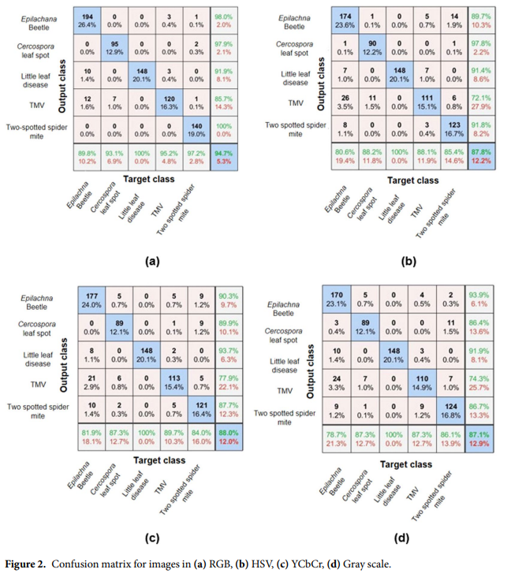

The architecture trained with RGB images resulted in a maximum mean classification accuracy of 95.1% and when the proportion of samples for each class was taken into consideration, the accuracy was 94.7% as shown in Fig. 2. The classification accuracy using the RGB images was the highest compared to the images in other color spaces. The result was in agreement with the earlier study which used visible RGB images for disease classification . It was surprising that the architecture trained with HSV had lower accuracy (87.8%) compared to RGB and YCbCr images as HSV was found to be one of the widely used color space for discriminating disease region from the healthy region27,28,31. With the grayscale image, the observed accuracy was lower (87.1%) as expected, compared to the images in other color spaces.

**Using VGG16 as feature extractor and MSVM for classifcation.**

In the second part of the study, features were extracted from the convolution layer 8 to the last dropout layer of one of the trained VGG16 models which produces the best result among the five trials. This procedure is repeated for image datasets from different color spaces. These features are given as input to the MSVM for classification of disease.

It was surprising to observe that features from fully connected layers were able to produce equal or better results compared to the classification layer of the original VGG16 model. In the case of RGB, YCbCr and grayscale, the accuracy improved marginally whereas in HSV it remained more or less equal to the value resulting from the original model.

**Leaf images in field condition.**

**Using VGG16 directly.**

In the case of leaf images in field condition, the convergence occurred within 5 epochs for all the color spaces. This clearly indicates that it has learned features faster compared to the leaf images in laboratory condition. The average accuracy for classification using RGB, HSV, YCbCr and grayscale were 99.4%, 98.5%, 99.4% and 98.1% respectively which demonstrates superior performance over the prior case.

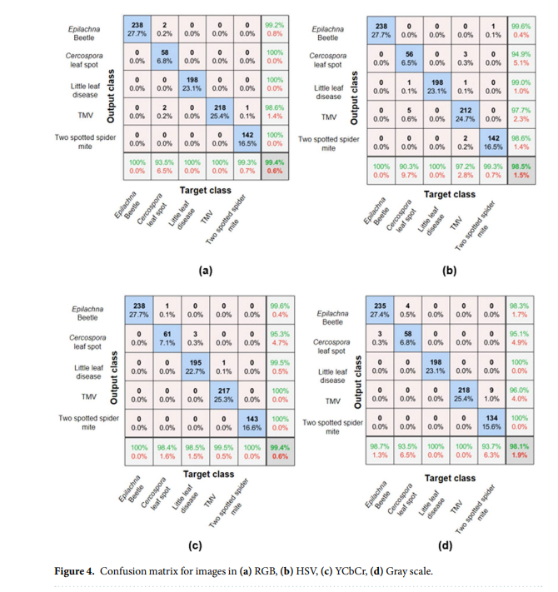

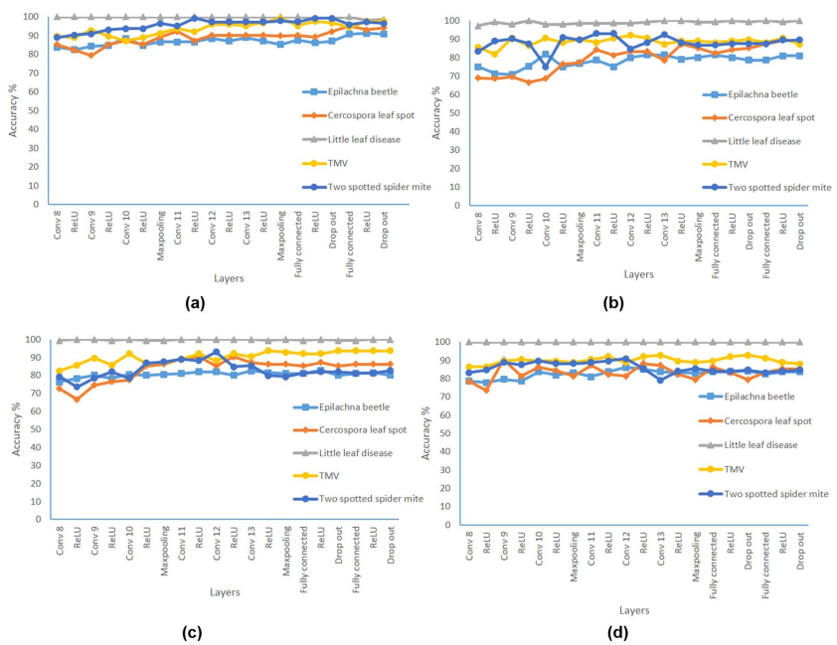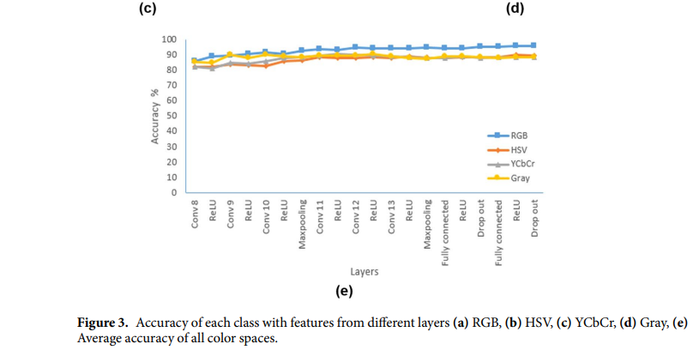

Using VGG16 as feature extractor and MSVM for classification.

In the second part, the resulting accuracy by using the features extracted from the different layers and training with MSVM. RGB features from the 8th convolution layer reported an accuracy of 100% for Epilachna beetle, little leaf and TMV whereas the classes Cercospora leaf spot and two spotted spider mite reported a lower accuracy of 88.7% and 90%, respectively. This shows that the features from the earlier convolution layer is sufficient for the above three classes which resulted in an accuracy of 100%.

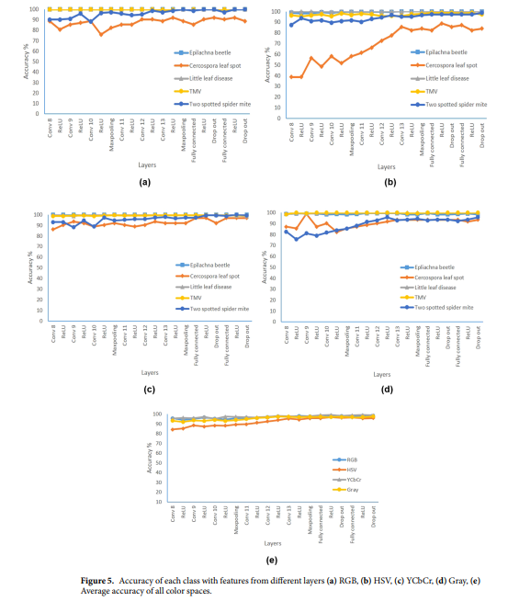

**PAPER- VIII**

*V. K. Shrivastava, M. K. Pradhan and M. P. Thakur, "Application of Pre-Trained Deep Convolutional Neural Networks for Rice Plant Disease Classification," 2021 International Conference on Artificial Intelligence and Smart Systems (ICAIS), 2021, pp. 1023-1030, doi: 10.1109/ICAIS50930.2021.9395813.*

**ABSTRACT**

Rice is a primary food and encounters an essential role in providing food security worldwide. However, several diseases affect this crop that significantly reduces its production and quality. Therefore, early detection of diseases is a much needed task to prevent spreading of diseases. Hence, it is desirable to develop an automatic system which will help agronomists, pathologists and even the farmers to diagnose the rice diseases more efficiently and take preventive measures in time. In the present era of advanced artificial intelligence, various learning techniques have been explored for rice plant disease classification. Among various machine learning techniques, deep learning has been widely applied in various domains of computer vision and image analysis recently. It has successfully delivered promising results with large potential. However, training the deep learning model from scratch requires huge labeled data and collection of huge labeled data is expensive, laborious and time taking process. Transfer learning of pre-trained deep learning models is a technique to overcome such problems. This paper has explored the performance of various pre-trained deep CNN models such as: (i) AlexNet; (ii) Vgg16; (iii) ResNet152V2; (iv) InceptionV3; (V) InceptionResNetV2; (vi) Xception; (vii) MobileNet; (viii) DenseNet169; (ix) NasNetMobile; and (x) NasNetLarge for image based rice plant disease classification. The dataset used in this paper consist of 1216 rice plant diseased images and these have been collected from the real agricultural field having seven classes: (i) rice blast; (ii) bacterial leaf blight; (iii) brown spot; (iv) sheath blight; (v) sheath rot; (vi) false smut; (vii) healthy leaves. The Vgg16 model resulted in the highest classification accuracy of 93.11%. The outcome of the model can be used as an advisory and as an early detection tool in the real agriculture domain.

**METHODOLOGY**

Rice plant disease dataset with 1216 images have been used in this experiment. This data set was created with images captured by two smartphone mobiles (Gionee and LYF mobile phones having 5.0 megapixel) and a digital camera (Canon PowerShot SX530HS with 16.0 megapixel). Adobe Photoshop CS5 (64 Bit) software tool has been used to pre-process the images to remove the other information by making the background black for the purpose of reducing the complexity and computational cost. All these images were acquired on various weather conditions from the agricultural field of Indira Gandhi Agricultural University that is situated in Raipur, Chhattisgarh state, India. The dataset contains seven classes: (a) Rice Blast (RB); (b) Bacterial Leaf Blight (BLB); (c) Brown Spot (BS); (d) Sheath Blight (SB); (e) Sheath Rot (SR); (f) False Smut (FS) and (g) Healthy Leaves (HL).

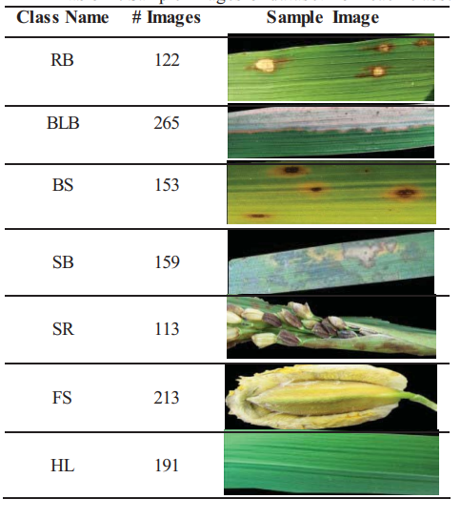

**Transfer Learning**

Deep CNN model has been applied widely and successfully for image classification tasks in various domains such as hyperspectral remote sensing, agriculture etc. However, training a deep CNN model from scratch requires a huge, labeled dataset, high computational hardware resources (GPUs) and high computation time. The collection of a large labeled dataset is a challenging task in the field like agriculture due to local weather conditions, indiscrimination of plant diseases, uncontrolled experimental field and rare-availability of experts. One solution to overcome such challenges is transfer learning, where pre-trained model on large dataset is used and acquired knowledge is applied for training on new dataset. In this way, it avoids the training of entire model from scratch resulting in requirement of less hardware resources and low computation time while achieving adequate classification accuracy on small labeled dataset.

**PRE-TRAINED DEEP CNN MODELS**

In this paper, we have explored 10 pre-trained deep CNN models namely :(i) AlexNet; (ii) VGG16; (iii) ResNet152V2; (iv) InceptionV3;(v) InceptionResNetV2; (vi) Xception; (vii) MobileNet; (viii) DenseNet169; (ix) NasNetMobile and (x) NasNetLarge.

They have provided all the experimental setup for training 10 deep CNN models for rice plant disease classification. We have reshaped our rice plant images to the desired shape as per the connected layer with seven neurons. This is done because all the 10 pre trained deep CNN models dealt here were trained on ImageNet dataset which is having 1000 classes and hence last layer consists of 1000 neurons. Whereas, the rice plant dataset used in this study is having seven classes and hence last fully connected layer should have seven neurons. Further, all the layers were frozen while training except last layer based on the concept of transfer learning as shown in the weights obtained from training of ImageNet dataset were retained while training for rice plant dataset and only the weights of last layer will be updated. Then, we have randomly partitioned the rice plant disease dataset into 70%, 20% and 10% training, test and validation set, respectively. Each model has been trained for 100 epochs with a mini-batch size of 8 and learning rate of 0.01.

RESULT

We have shown the classification accuracy for each trial along with OA and STD of five trials. It can be observed that the highest OA of 93.11% with STD of 3.02% has been obtained by applying VGG16 model.

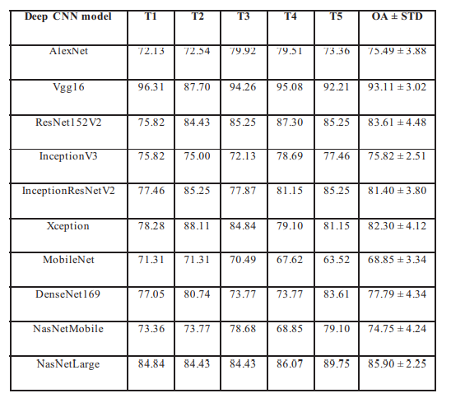

It can be observed that the performance of VGG16 model for SR, FS and HL classes were mostly accurate whereas RB and BLB classes were difficult to classify. Moreover, the performance graph with respect to loss vs. epoch and accuracy vs epoch has been depicted.

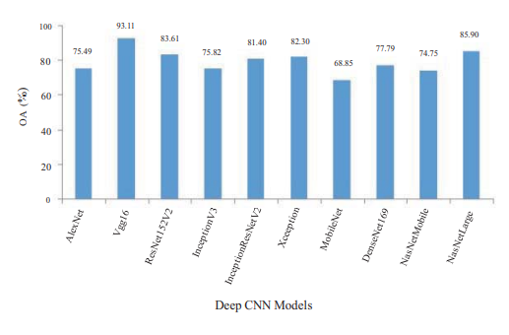

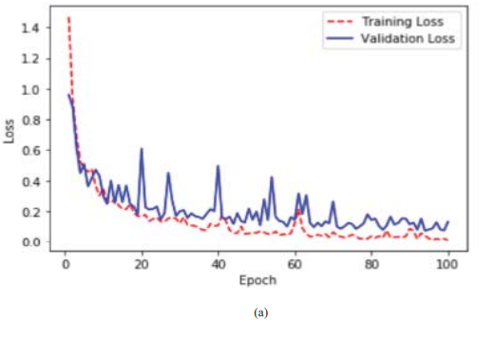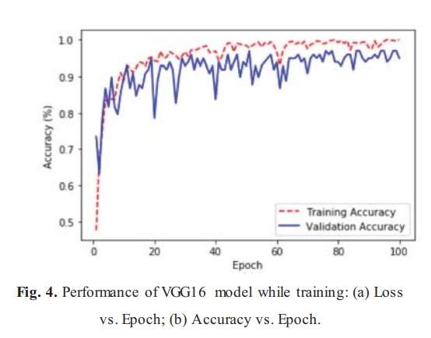

The paper presents an image-based rice plant disease classification using transfer learning of deep CNN models. We employed 10 pre-trained deep CNN models namely: AlexNet, VGG16, ResNet152V2, InceptionV3, InceptionResNetV2, Xception, MobileNet, DenseNet169, NasNetMobile and NasNetLarge. Our results showed that the VGG16 model obtained the highest classification accuracy of 93.11% among the 10 models.

**HIMA RANI MATHEWS - 19BCE1532**

**PAPER - IX**

*Prabhakar, M., Purushothaman, R., & Awasthi, D. P. (2020).* ***D*eep learning based assessment of disease severity for early blight in tomato crop***. Multimedia Tools and Applications, 79(39-40), 28773–28784. doi:10.1007/s11042-020-09461-w*

**ABSTRACT**

Assessment of disease severity is one of the major challenges which helps in the prediction of yield quantitatively and to decide the control factors that improve the yield of any crop. Hence a perfect system is essential to measure the severity level of the disease in order to improve its productivity. An intelligent state-of-the-art technique i.e., deep learning plays an inevitable role in most real-time applications including smart farming. Tomato crops are frequently affected by a dangerous fungal disease i.e., early blight, resulting in 100% production loss to farmers. In this work, an identification of early blight disease in tomato leaves is performed by a paper microscope named Foldscope. Further, a deep Residual Network101 (ResNet101) of Convolutional Neural Network (CNN) architecture is used to measure the severity level of early blight disease in tomato leaves. The dataset in the model is trained by using an open database i.e., PlantVillage dataset for mild, moderate, and severely diseased leaves along with healthy tomato leaves. The results of ResNet101 architecture is compared with other pre-trained CNN such as Visual Geometry Group16 (VGG16), VGG19, GoogLeNet, AlexNet, and ResNet50. Among these networks, the deep ResNet101 architecture has achieved the highest accuracy of 94.6%

**METHODOLOGY**

1. **Disease identification using Foldscope**

The infected tomato leaves are collected from an agricultural field. Staining procedure is performed on the portions of infected leaves. The pathogen was isolated in Potato Dextrose Agar. (PDA) medium at a temperature of 27 °C nearly for ten days. The colonies are formed after ten days of inoculation and the specimen are stuck with the glass slide for analyzing the colonies. The specimen slide is inserted into the Foldscope and the light source is provided by a LED magnifier. The sample is viewed by adjusting the panning guide and focus ramp. The (magnetic) coupler is used to attach the Foldscope with a mobile phone. Hence, better visualization of micro-organisms is obtained by further zooming the mobile camera. By proper focusing and zooming, the presence of Alternaria solani can be captured.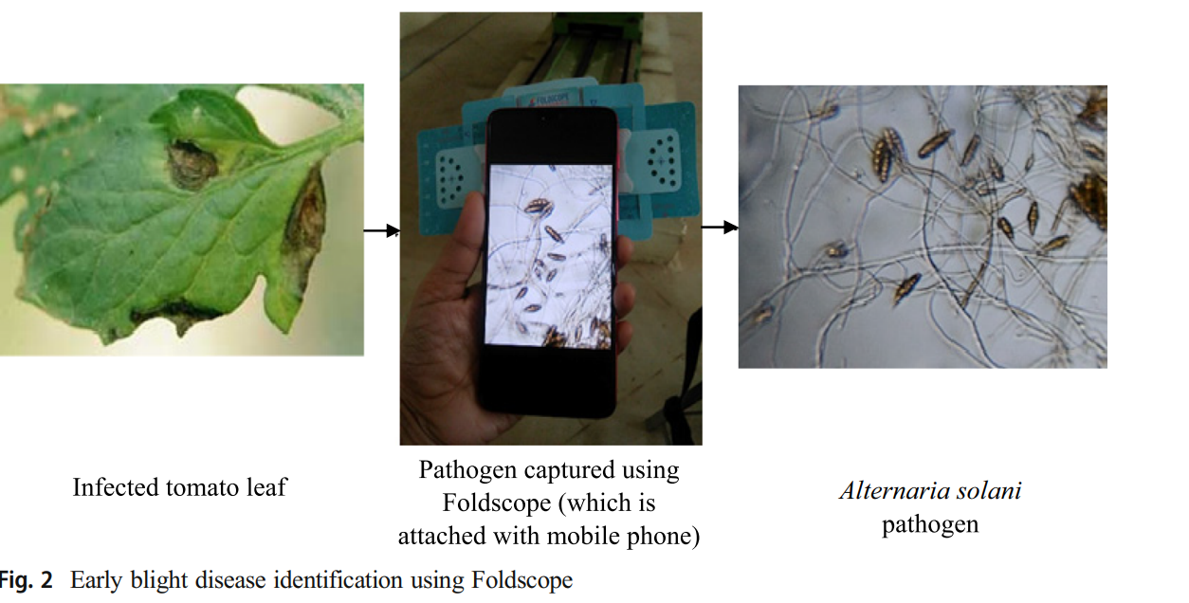

1. **Severity measurement using ResNet101 based CNN**
2. **Deep ResNet101 CNN**

In deep CNN, the classification is done by end-to-end multilayer fashion and the low, mid, and high-level features can be improved by the number of stacked layers. When the network depth is increasing, it is very difficult to train the network. Also, saturation in accuracy level occurs with rapid degradation in the performance. These problems were solved by residual learning.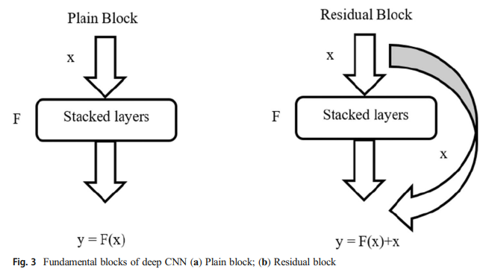

The underlying concept is in place of trying to learn some features, residual is learned by the network itself. Residual means subtraction of features learned from the input of that layer. In residual learning, shortcut connection is used to connect the input of ith layer directly to some i+xth layer.

In residual learning, instead of mapping y = F(x), the residual of x is also added to F(x) i.e., y = F(x) + x. Hence it is easier to map the residual than the original, and also optimal results can be achieved. The variants of the residual network are ResNet18, ResNet50, ResNet101, ResNet152 and ResNet201. In this proposed work, the ResNet101 architecture is used to predict the severity level in tomato leaves, and the results are compared with other pre-trained networks such as VGG16, VGG19, GoogLeNet, AlexNet, and ResNet50. The ResNet101 network has more deep layers and it can give rich feature representations than the other variants of the residual network. Hence it is used in this proposed network.

1. **Dataset**

In this proposed method, an open-access database of PlantVillage dataset [12], which consists of more than 50,000 images with 38 class labels is used as a data material. The data material consists of images from healthy tomato labels as well as early blight disease. In an early blight category, there are 1000 of images mixed with mild, moderate and severe stages of early blight. Among these, 100– 300 images were selected for each category (i.e., mild, moderate and severe early blight) which was certified by a plant pathologist. One dark spot surrounded by concentric rings is considered as mild early blight, two or three dark spots surrounded by concentric rings is considered for moderate early blight and more than 3 spots with severe infection or one-half side of the leaf totally spoiled were considered for severe early blight category.

**(c) Data Augmentation**

One of the problems associated with the small dataset is over-fitting i.e., the network performing well in the training set (with small error) but during the test set i.e., for new data, it will not perform well (generates more error). In this work, a distinct form of data augmentation is performed using label preserving transformations. Also, it is more useful when the size of the dataset is very small. Transformations used to create the augmented images are rotation, translation, and scaling. The rotation range of ±20° and translation range in both x and y directions of ±5 units have been applied to the original images in order to obtain the augmented images. The resultant dataset consists of 2388 images, in which 70% and 30% (i.e., 1672 and 716) of images are employed for the training and testing phase, respectively.

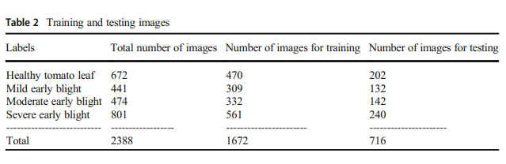

**(d) Experimental setup**

The ResNet101 architecture is used to predict the degree of severity label (such as mild, moderate and severe) of early blight in tomato leaves. The architecture is composed of the number of convolutional layers (with non-linear functions), pooling and fully connected layers.

* The sample of tomato leaves was taken from the Plant village dataset, which contain preprocessed images of size 256 × 256.
* In the preprocessing stage, the images are resized according to the size of the pre-trained network architecture, such as 227X227 for AlexNet and 224X224 for the remaining pre-trained networks.
* Before the softmax layer, the network has a fully connected layer in which neurons are fully connected with all activations in the preceding layer.
* Finally, the softmax layer is used to predict the severity label based on the probability. The feature extraction is done on the input images using kernels by performing the convolutional operations in the convolutional layers of deep CNN

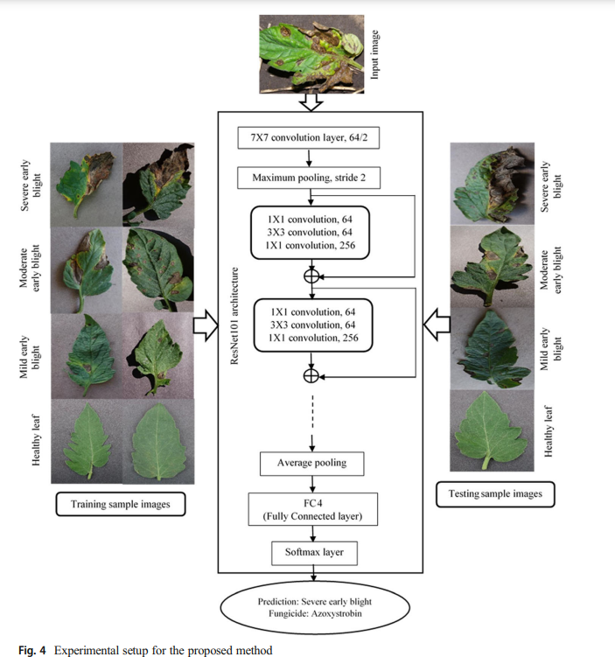

* The Rectified Linear Unit (ReLU) nonlinear function is used in the ResNet101 architecture. The number of parameters and computations are reduced by employing pooling layers. Maximum pooling is used in this architecture which takes the maximum value after performing the spatial size reduction.
* Fine-tuning is done on the fully connected layer of ResNet101 architecture. To obtain accurate results, appropriate parameters are used for initialization rather than arbitrary values. Based on the number of traits, the learning rate for fine-tuning is selected as 0.0001. The experiments are executed using windows 10 processor with Intel® Core™ i5-6200U, 8GB RAM and 2.4GHz processor speed. Programs are coded in MATLAB (R2018a) version.

**RESULT**

An intelligent system for assessment of disease severity in early blight of tomato leaves was developed using a Foldscope (recently invented paper microscope) and deep ResNet101 CNN architecture. Before severity assessment, disease identification was performed employing Foldscope and then the severity levels (such as mild, moderate, severe and healthy leaves) were categorized using pre-trained architectures such as VGG16, VGG19, GoogLeNet, AlexNet, ResNet50 and ResNet101 CNN. In order to compare the performance of ResNet101, the same trial has been done with the earlier pre-trained deep learning models i.e., VGG16, VGG19, GoogLeNet, AlexNet and ResNet50. The ResNet101 shows the highest accuracy of 97.6% in the training phase and 94.6% in the testing phase when compared with other architectures i.e., VGG16, VGG19, GoogLeNet, AlexNet and ResNet50. ResNet101 pretrained network outperforms than the other networks, since it reduces the gradient vanishing problem occurring in neural networks which degrades the performance of the network.

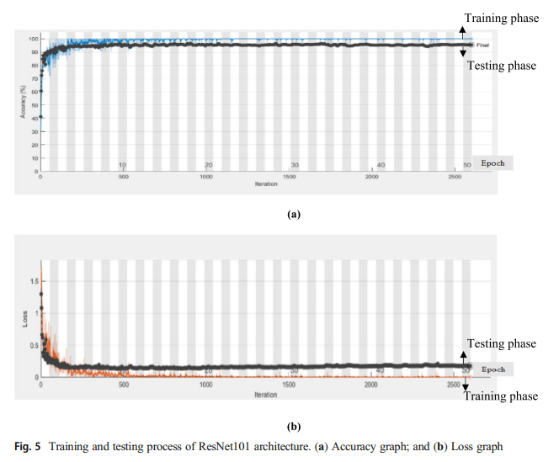

As a result of this training and testing process, the accuracy can be analyzed using an error matrix or confusion matrix which visualize the performance in the form of table layout using performance metrics such as precision, recall, accuracy, etc. While comparing the accuracies among all the pre-trained networks, it is found that the least accuracy in both training and testing phase i.e., 90.5% and 85.1% is obtained by VGG16 and highest accuracy i.e., 97.6% and 94.6% is obtained by proposed method using ResNet101 architecture.

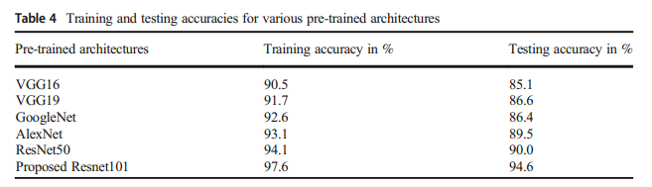

In VGG16 confusion matrix, all the healthy leaves are classified correctly. Among 132 of mild early blight leaves, only 121 are classified correctly, and 11 are misclassified. In the moderate category, more misclassification occurs compared to ResNet101 architecture. Among 142 of moderate category, only 62 are correctly classified, and the remaining are misclassified. Better classification was found in severe blight category. Finally, a total accuracy of 85.1% is obtained in the testing phase of VGG16 model against 94.6% of ResNet101 architecture.

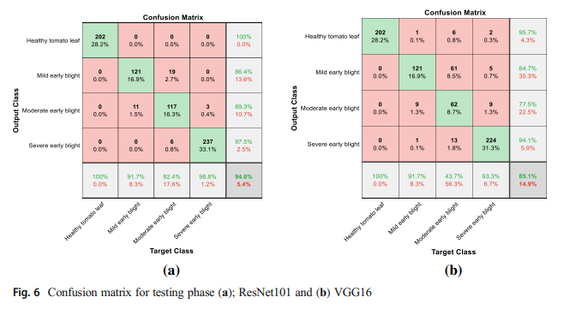

**PAPER - X**

*Srivastava, S., Kumar, P., Mohd, N., Singh, A., & Gill, F. S. (2020).* **A Novel Deep Learning Framework Approach for Sugarcane Disease Detection.** *SN Computer Science, 1(2). doi:10.1007/s42979-020-0094-9*

**ABSTRACT**

Sugarcane, belonging to the grass family Poaceae, is rich in the sugar sucrose, thereby used for making white sugar, jaggery, and other by-products like molasses and bagasse. However, a diseased sugarcane plant is of no use, so it needs to be detected as soon as possible. A novel deep learning framework approach is proposed in this paper to detect whether a sugarcane plant is diseased or not by analyzing its leaves, stem, color, etc. The study comprises three scenarios based on different feature extractors namely Inception v3, VGG-16, and VGG-19. These are the pertained models on which different classifiers are trained. The state-of-the-art algorithms (SVM, SGD, ANN, naive Bayes, KNN, and logistic regression) are compared with deep learning algorithms like neural networks and hybrid AdaBoost. Several statistical measures such as accuracy, precision, specificity, AUC, and sensitivity are calculated using Orange software, and the scenario that has the highest accuracy is chosen. The receiver operating characteristic curve is computed in order to assess accuracy. An AUC of 90.2% is obtained using VGG-16 as the feature extractor and SVM as the classifier.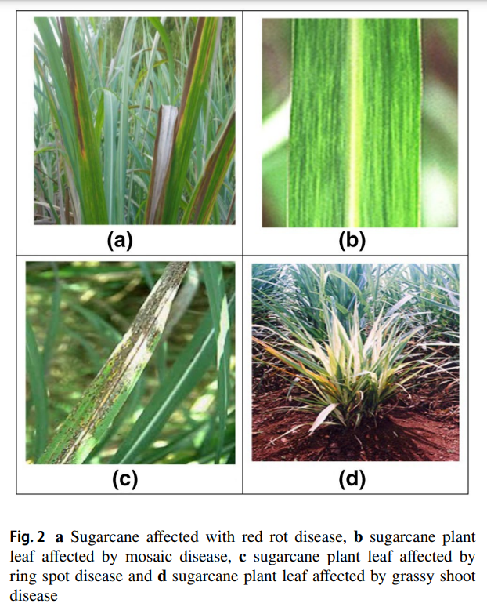

**Diseases of Sugarcane**

Sugarcane plants can be affected by many types of diseases caused by some bacteria, fungi, viruses, protozoans, or phytoplasma. Some of the sugarcane diseases are red rot, mosaic disease, ring spot, and grassy shoot.

**Dataset Formation**

The dataset was formed by collecting images of diseased and non-diseased sugarcane from Mawana Sugar Mill Pvt. Ltd. It was then divided into two sets—training set and test set. A total of 160 images were present in the training set and 80 images in the test set.

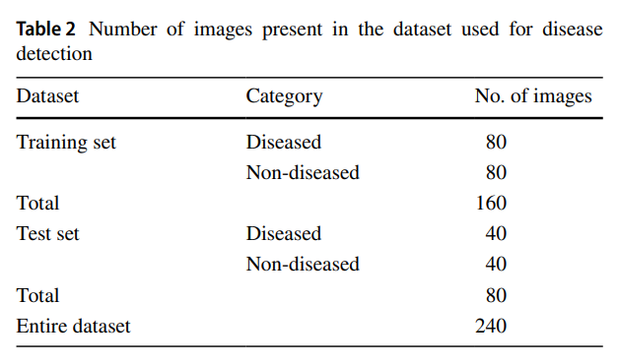

**METHODOLOGY**

Three scenarios use different types of feature extractors namely Inception v3, VGG-16, and VGG-19. These features are then scrutinized using seven classifiers namely support vector machine (SVM), KNN (K-nearest neighbor), neural network (NN), stochastic gradient descent (SGD), AdaBoost, logistic regression (LR), and Naive Bayes. They have used Orange software for this purpose. Orange is an open-source data mining toolkit used for visualization of data, machine learning, and data analysis.

**Scenario 1**

In Inception v3, the novel deep learning model is used as a feature extractor in this scenario. The features that are extracted are then fed to different classifiers. Inception v3 consists of two parts. The first part consists of feature extraction with CNN, and the second includes classification using softmax and fully connected layers. Logistic regression gives the best accuracy for the Inception v3 model. They obtain an AUC value of 0.917 and CA of 0.838 using logistic regression.

**Scenario 2**

A VGG-19 novel deep learning model is used as a feature extractor in this scenario. The features that are extracted are then fed to different classifiers [12]. VGG-19 is a 19-layer network. VGG-19 obtains 9.0% error rate. The best accuracy for the VGG-19 model is given by stochastic gradient descent (SGD). They obtain an AUC value of 0.863 and CA of 0.863 using SGD.

**Scenario 3**

It uses VGG-16 deep learning model as a feature extractor for the dataset. The extracted features are then fed to different classifiers. A VGG-16 model is a pre-trained deep learning model. It is a 16 weight layered network consisting of multiple 3×3 kernel-sized filters, trained on the ImageNet dataset. In a traditional VGG-16 model, the depth of the network is increased so that more complex features can be learned. The convolutional layers in VGG are followed by three fully connected layers. An AUC of 90.2% is obtained using VGG-16 as the feature extractor and SVM as the classifier.

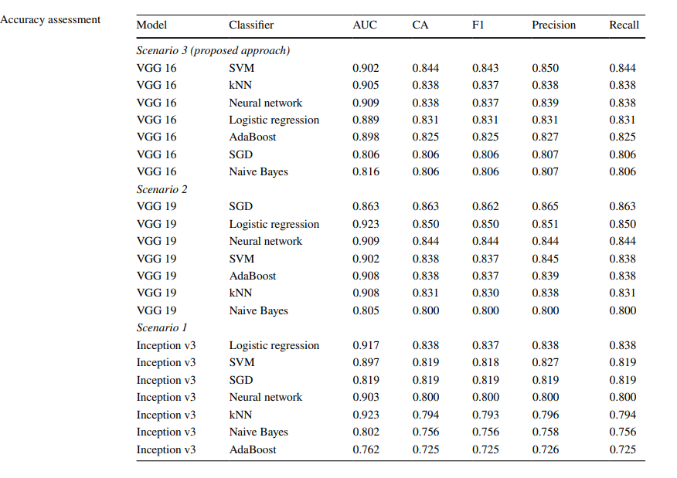

**Orange Scoring Methods**

The Orange Data Mining Library provides the following scoring methods on the basis of which a classifier works. The test and score widget is used for this purpose. It scores the classifiers on the basis of these classifiers by using scoring methods like AUC, CA, F1, precision, and recall.

*AUC (Area Under Curve)* This value shows the performance of the proposed model. The closer the value of AUC is to 1, the higher is the level of perfection of the model. In our case, the AUC for the proposed approach is 0.902.

*CA* It is used for the calculation of the classification accuracy which shows how efficiently does the deep learning algorithm classify the images in a dataset, in our case, classification between diseased and non-diseased sugarcane.

*F1* It is used for computing the balanced F-score or F-measure. 1 is considered as the best value of F1, and 0 is considered as its worst value.

*Precision* It is calculated by dividing tp by the sum of tp and fp where tp denotes the number of true positives and fp denotes the number of false positives.

*Recall* It is calculated by dividing tp by the sum of tp and fn where tp denotes the number of true positives and fp denotes the number of false negatives.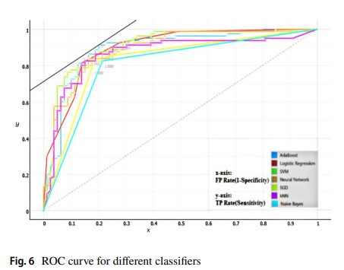

The performance of the framework is evaluated by plotting the ROC curve. For evaluating the performance of a multi-class classification curve, the receiver operating characteristics (ROC) curve is plotted. It is a probability curve. ROC is plotted with the total positive rate (TPR) on the y-axis and FPR (false positive rate) on the x-axis. The x-axis of the ROC curve shows the “1-specificity” value, and the y-axis of that shows “sensitivity”.

**RESULTS**

Out of the three scenarios, the proposed work is chosen by considering the highest classification accuracy (CA) value. If the CA value is the same for the two models, then the comparison is done on the basis of the AUC (area under the curve) value. Since, VGG-16, VGG-19, and Inception v3 do not have the same CA values, VGG-16 is chosen as it has a maximum CA value of 0.844. SVM can also be applied after using extreme learning machines (EMLs) which operate on feed-forward networks having only one layer hidden. Three different feature extractor models, namely VGG-16, VGG-19, and Inception V3, were used for extracting features. The output from the feature extractor models was then fed to seven different classifiers, namely naive Bayes, AdaBoost, neural network, stochastic gradient descent, K-nearest neighbor, support vector machine, and logistic regression; based on the CA and AUC values obtained, VGG-16 was chosen as the feature extractor model and SVM as the classifier. SVM was able to classify sugarcane as diseased and non-diseased with the highest AUC, i.e., 90.2%.